Sri Lanka Institute of Information Technology



Lab Submission Lab sheet 08

IT23782204

Pathiraja M.M.S

Probability and Statistics - IT2120

B.Sc. (Hons) in Information Technology

**Exercise**

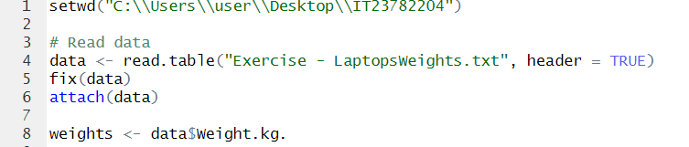

01)

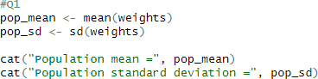

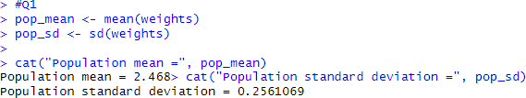

02)

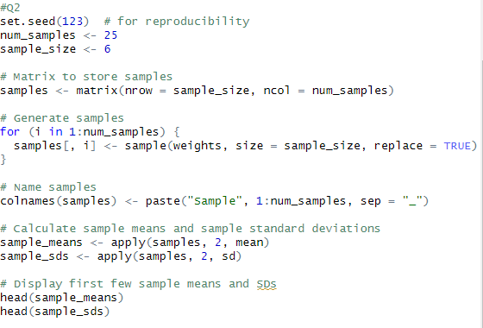

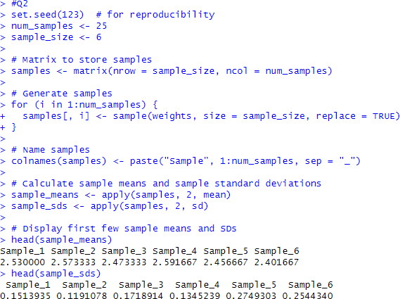

03)

